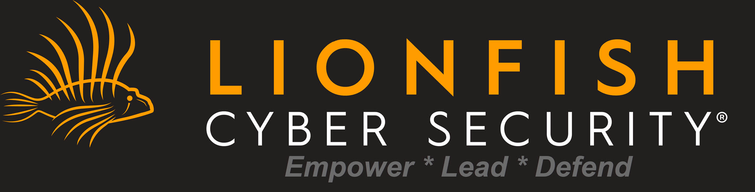

CSA GRANT APPLICATION CHECKLIST
CAIP High School Program - Certified Artificial Intelligence Practitioner

📅 IMPORTANT DATES
Grant Window Opens: | March 1, 2026
Application Deadline: | May 15, 2026
Program Start: | Fall 2026

✓ ELIGIBILITY REQUIREMENTS
☐ Indiana resident
☐ Currently enrolled in grades 9-12 at an Indiana high school
☐ Minimum 2.0 GPA (or equivalent)
☐ Interest in technology, AI, or cybersecurity careers
☐ Commitment to complete 72+ hour program

📄 REQUIRED DOCUMENTS
☐ Birth Certificate or Passport
Proof of age and identity
☐ Proof of Indiana Residency
Utility bill, lease, or official mail dated within 60 days
☐ Current School Transcript
Official or unofficial showing current enrollment and GPA
☐ Parent/Guardian ID
If student is under 18
☐ Signed Consent Form
Parent/guardian signature required for minors

📋 STEPS TO COMPLETE BEFORE MARCH 1ST
Step 1: Gather all required documents listed above
Step 2: Request official transcript from your school counselor
Step 3: Have parent/guardian review program requirements
Step 4: Create a ScholarTrack account at scholartrack.indiana.gov
Step 5: Set a reminder for March 1st to submit application

💼 WHY THIS CERTIFICATION MATTERS
The Certified Artificial Intelligence Practitioner (CAIP) certification provides value across ALL career fields, not just technology. Whether you pursue healthcare, business, education, manufacturing, or creative industries, AI literacy is becoming essential. This certification demonstrates your ability to understand, evaluate, and ethically implement AI solutions—skills that employers in every sector are actively seeking. Students who earn this certification position themselves for higher starting salaries and faster career advancement regardless of their chosen field.

📞 QUESTIONS? CONTACT US
Lionfish Cyber Security
Email: education@lionfishcybersecurity.com
Phone: (877) 732-6772
Website: lionfishcybersecurity.com

